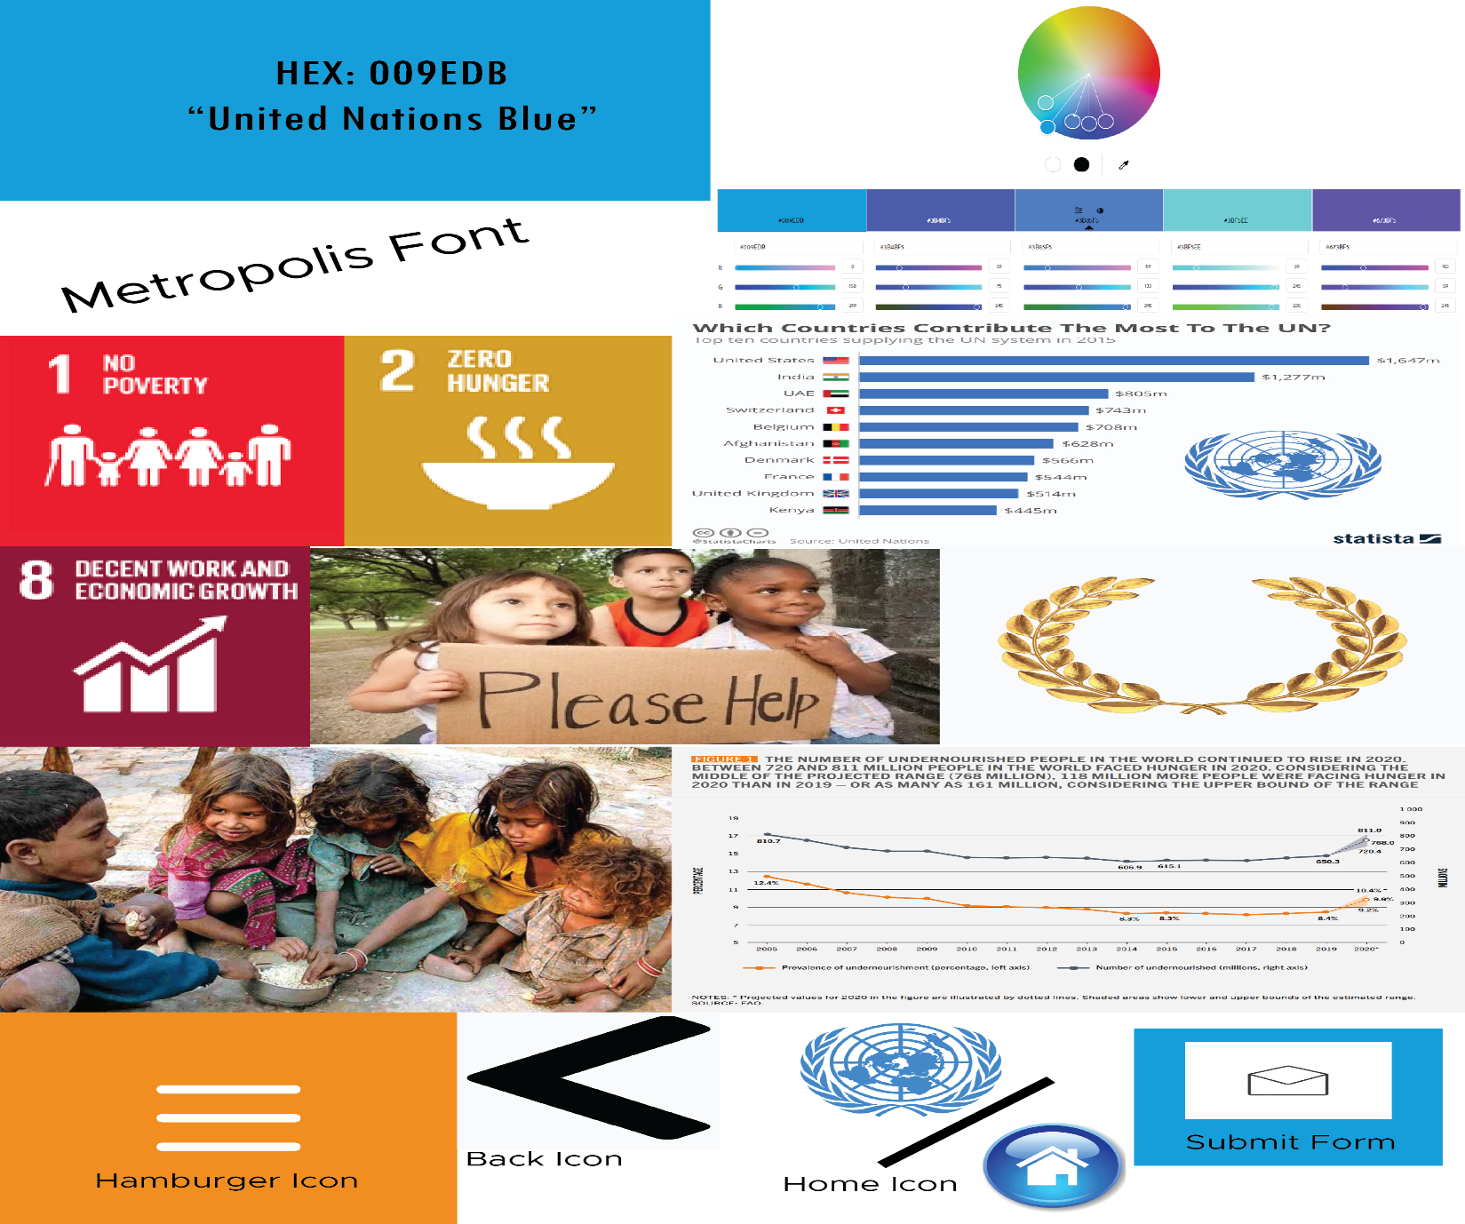

Graphs are a great way of showing information. There could be graphs on the website to show different statistics. This would be under the development goals page.

The submit form button should stay consistent with the website’s colours. Furthermore, the home menu icon could either be a home symbol or the website’s own icon. Both are intuitive ways of navigating back to the home/index page.

This complementary colour grid helps find other colours for buttons such as submit, back or home. The colours from the second last to the right are: #3B4BF5, #3B85F5, ##3BF5EE, #673BF5

The back and hamburger icons are iconic website navigation iconography. This is consistent with other websites, allowing the user to intuitively navigate with little learning curves.

Pictures can help tell stories in just a glance. Having both infographics and photos allows to portray information and imagery related to the goals of the website. We will be covering “No “Poverty, “Zero Hunger” and “Decent work and Economic Growth.”

The Metropolis font is an extremely effective font regarding website design. As a sans serif font, it is clean and “not busy” allowing for readers to engage with the website more easily than a serif font (such as Times New Roman.)

United nations Blue gives a sense of authority and an be used for most buttons. The hex code is also displayed.